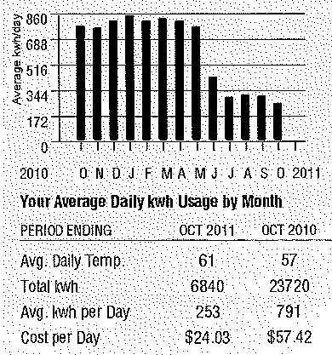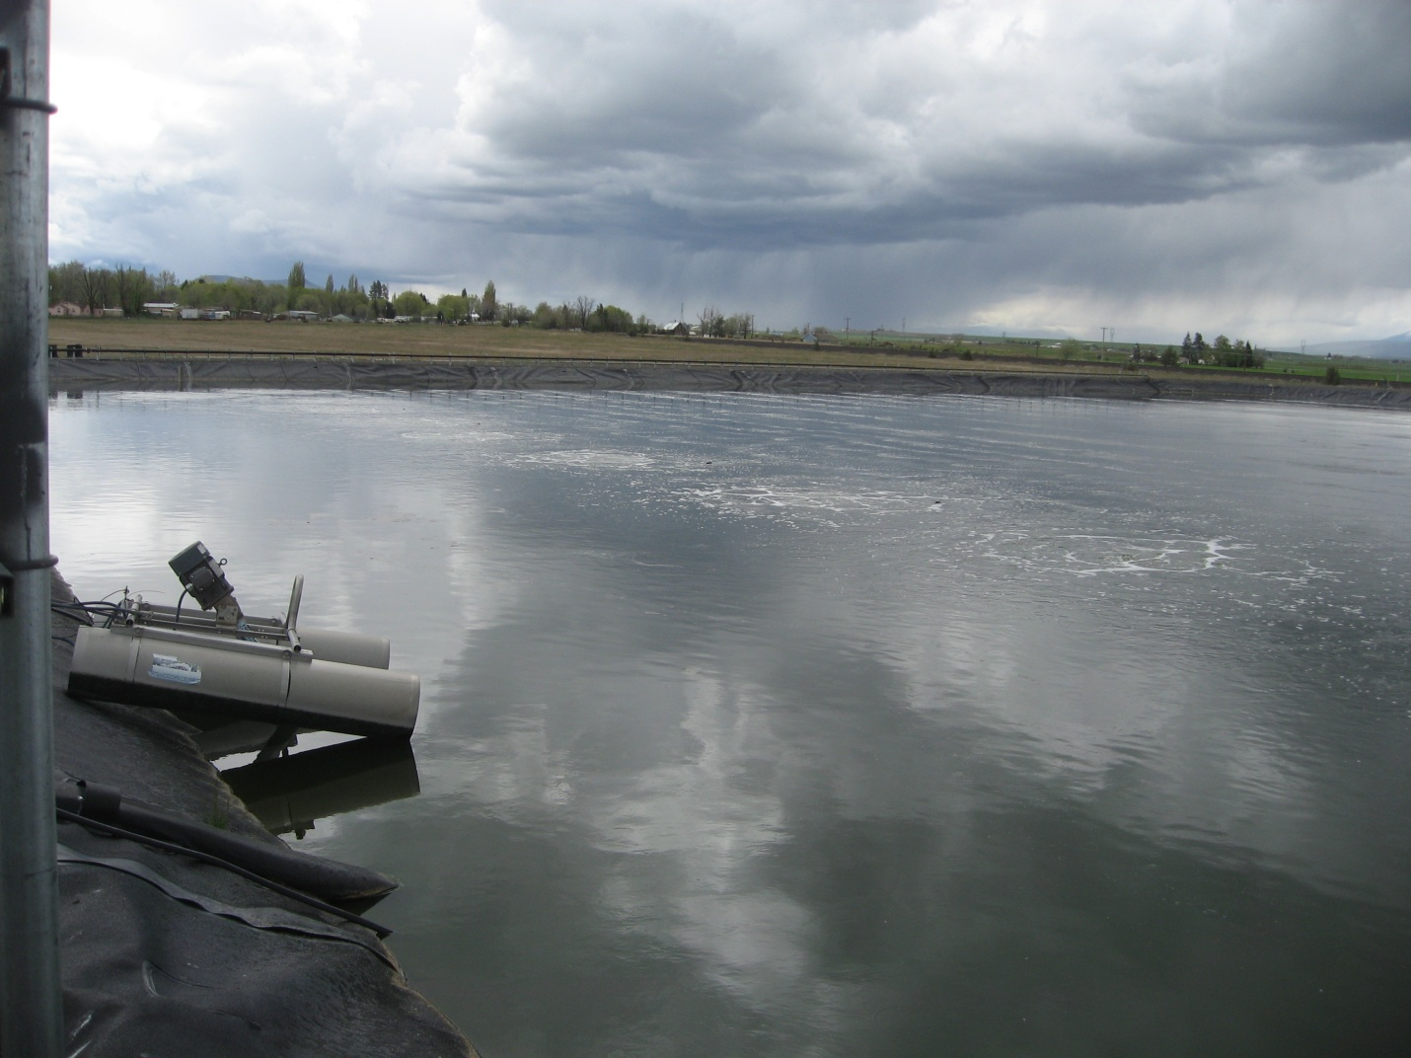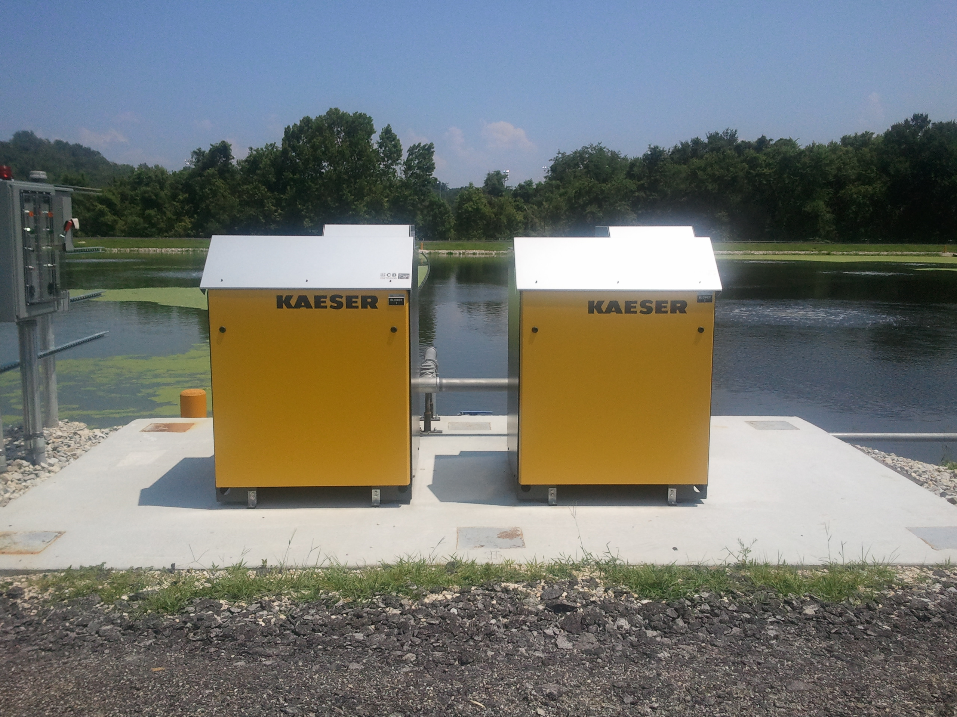

**The City of Metolius was looking for ways to improve treatment and save electricity at its wastewater treatment plant. After careful evaluation, the city selected Air Diffusion Systems® fine bubble aeration to replace it’s eight (5 HP) surface aerators. By aerating from the bottom up instead of top down like surface aerators, ADS aeration improves DO concentrations at all levels of the water column. ADS aeration delivers one of the highest oxygen transfer rates of any aeration device commercially available (3% / foot of water depth).**

**The ADS system improved treatment while reducing horsepower by 81%**

**City of Metolius WWTP**

**Upgraded Plant to ADS Fine Bubble Aeration : June 2011**

**Improved Treatment**

**Original System HP : 40**

**New System BHP : 7.8**

**Annual Electrical Savings ~ $10,500 – $13,000**

**No Dewatering for Installation**

**No Odors**

**Very Low Maintenance**

|  |  |
| --- | --- |
| **Effluent Permit Limits** | |
| **BOD** | **< 30 mg/l** |
| **TSS** | **< 75 mg/l** |

|  |  |
| --- | --- |
| **Lagoon Characteristics** | |
| **Volume** | **4.25 MG** |
| **Design Flow** | **0.127 MGD** |
| **Max Depth** | **10 feet** |
| **Retention Time** | **34 Days** |
| Influent **BOD** | **295 mg/l** |
| **Influent TSS** | **300 mg/l** |

**An Air Diffusion Systems Press Release**

**© Copyright 2011. All Rights Reserved**

Exploring new ways to save energy, the ADS way!

**Metolius Wastewater Treatment Facility – Metolius, OR**

**Air Diffusion Systems**

**The ADS system improved treatment while reducing horsepower by 81%**

**3964 Grove Ave - Gurnee, IL 60031**

**For additional information or a free cost estimate, contact:**

**Tom Hinde**

**Tom@airdiffusion.com**

**847-782-0044 – office**

**www.airdiffusion.com**

**Water treatment experts with more than 50 years of experience in the industry.**

**For More Information Contact John Hinde:**

**Phone (847) 782-0044**

**Email** [**john@airdiffusion.com**](cbsmithco@sbcglobal.net)

**Web www.airdiffusion.com**



**An Air Diffusion Systems Press Release**

**© Copyright 2011. All Rights Reserved**

|  |  |
| --- | --- |
| Lagoon Characteristics | |
| Volume | 8.7 MG |
| Design Flow | 0.3 MGD |
| Max Depth | 9 feet |
| Retention Time | 29 Days |
| Influent BOD | 200 mg/l |
| Influent TSS | 200 mg/l |

**Air Diffusion Systems**

**Water treatment experts with more than 50 years of experience in the industry.**

**For More Information Contact John Hinde:**

**Phone (847) 782-0044**

**Email** [**john@airdiffusion.com**](cbsmithco@sbcglobal.net)

**Web www.airdiffusion.com**

|  |  |
| --- | --- |
| Effluent Permit Limits | |
| BOD | < 45 mg/l |
| TSS | < 70 mg/l |

Festus Interim West WWTF

Upgraded Plant to ADS Fine Bubble Aeration : June 2011

Improved Treatment

Original Surface Aerator HP : 45

New Aeration System BHP : 10

Annual Electrical Savings ~ $12,706

Cut Disinfection Costs By 50%

City Installed Entire System

No Dewatering for Installation

No Odors

Very Low Maintenance

The City of Festus was looking for ways to improve treatment and save electricity at its wastewater treatment plant. Like many places, Festus’s Surface aerators were unable to meet the oxygen demand exerted by the influent waste. Successful long-term wastewater treatment is achieved by exceeding the oxygen demand of the influent waste while providing additional dissolved oxygen levels capable of supporting aerobic life.

After careful evaluation, the city selected Air Diffusion Systems® (ADS) aeration to replace it’s six (7.5 HP) surface aerators. By aerating from the bottom up instead of top down like surface aerators, ADS aeration improves DO concentrations at all levels of the water column. By increasing DO at the sludge water interface, aerobic life forms thrive using the sludge and built up organics as a food source. ADS aeration delivers one of the highest oxygen transfer rates of any aeration device commercially available (3% / foot of water depth).

The upgraded ADS system substantially reduced electrical usage by 78%. This system qualified for a grant of $12,706 from Ameren UE based on the first year of electrical savings!

**Air Diffusion Systems Lagoon Rejuvenation**

**Festus Interim West Wastewater Treatment Facility – Festus, MO**

**The ADS system improved treatment while reducing horsepower by 78%**

Exploring new ways to save energy, the ADS way!

**Air Diffusion Systems**